Hala Hany Mohammed

4221325

C1

Get customers that its contact First Name starts with 'je' or ‘le’.

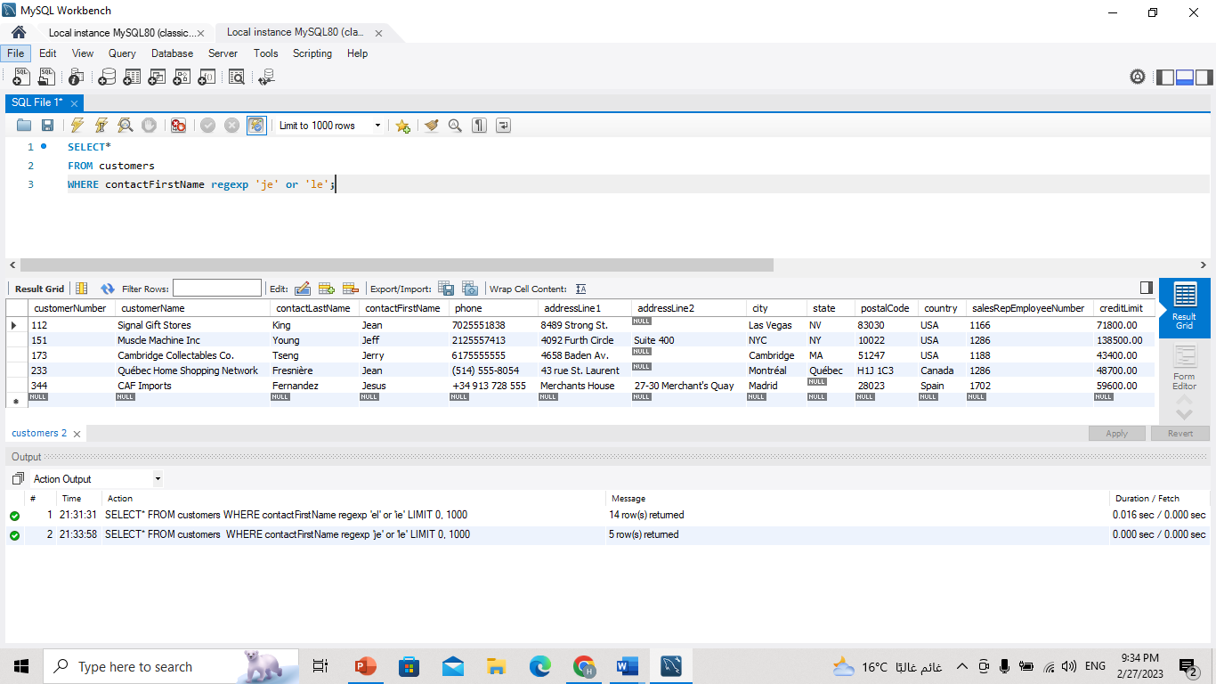

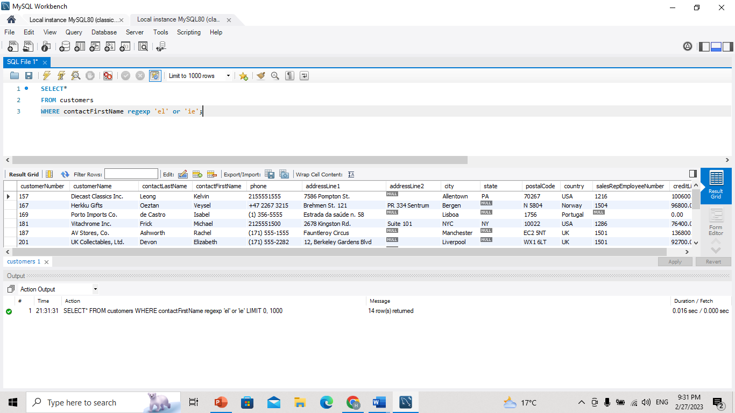Get customers that its contact First Name is ended with 'el' or contains ‘ie’.

Get customers that its contact First Name contains 'b' followed by g or a.

